**ASSIGNMENT 35.1**

**QUESTION 1 :-**

Create a employee table in Mysql and columns as Emp_id, Emp_name, Dept_name(Hadoop Developer), Emp_sal. Import the employee table contents into the HDFS directory using Sqoop.

**Step 1**: Create a database and table in mysql and insert the data into the table

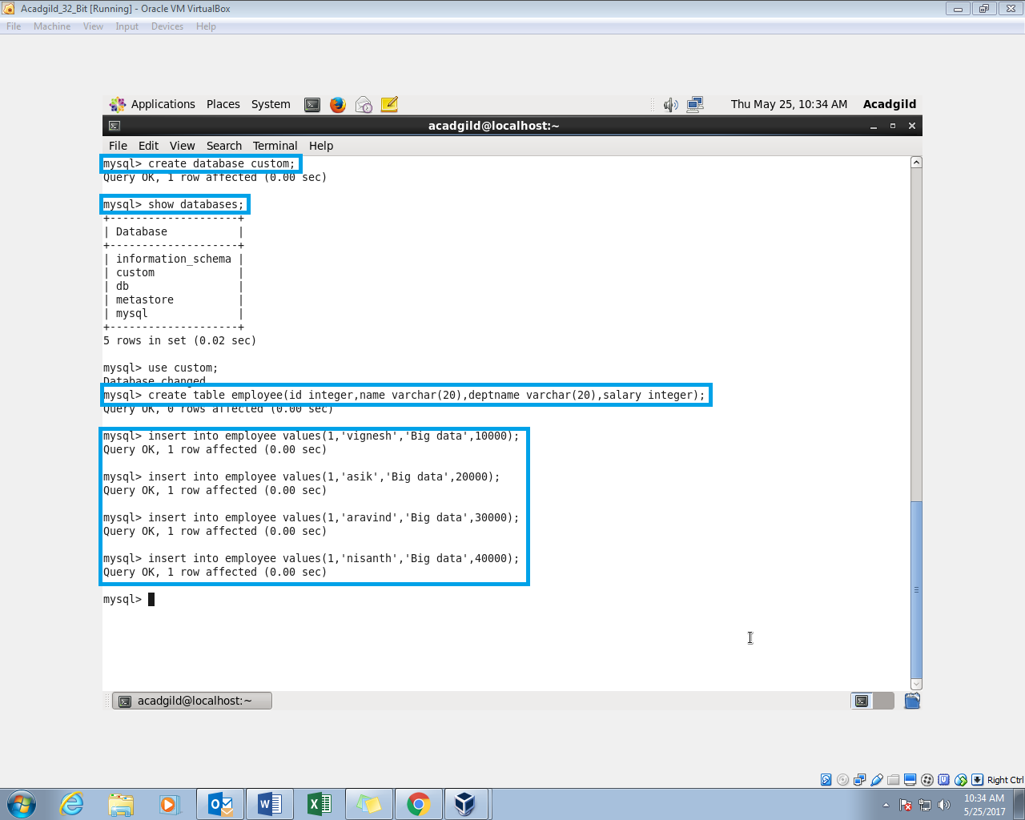

**Step 2**: Display the contents of the table employee

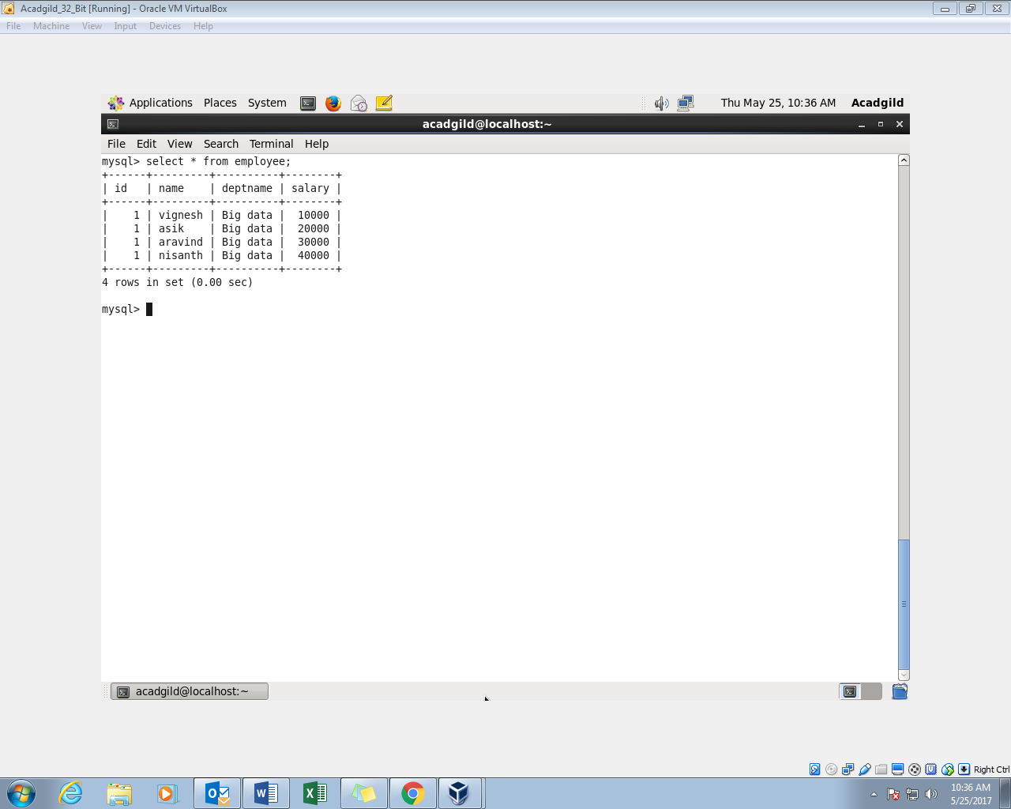

**Step 3**: Import the data in MySQL to hdfs by giving password

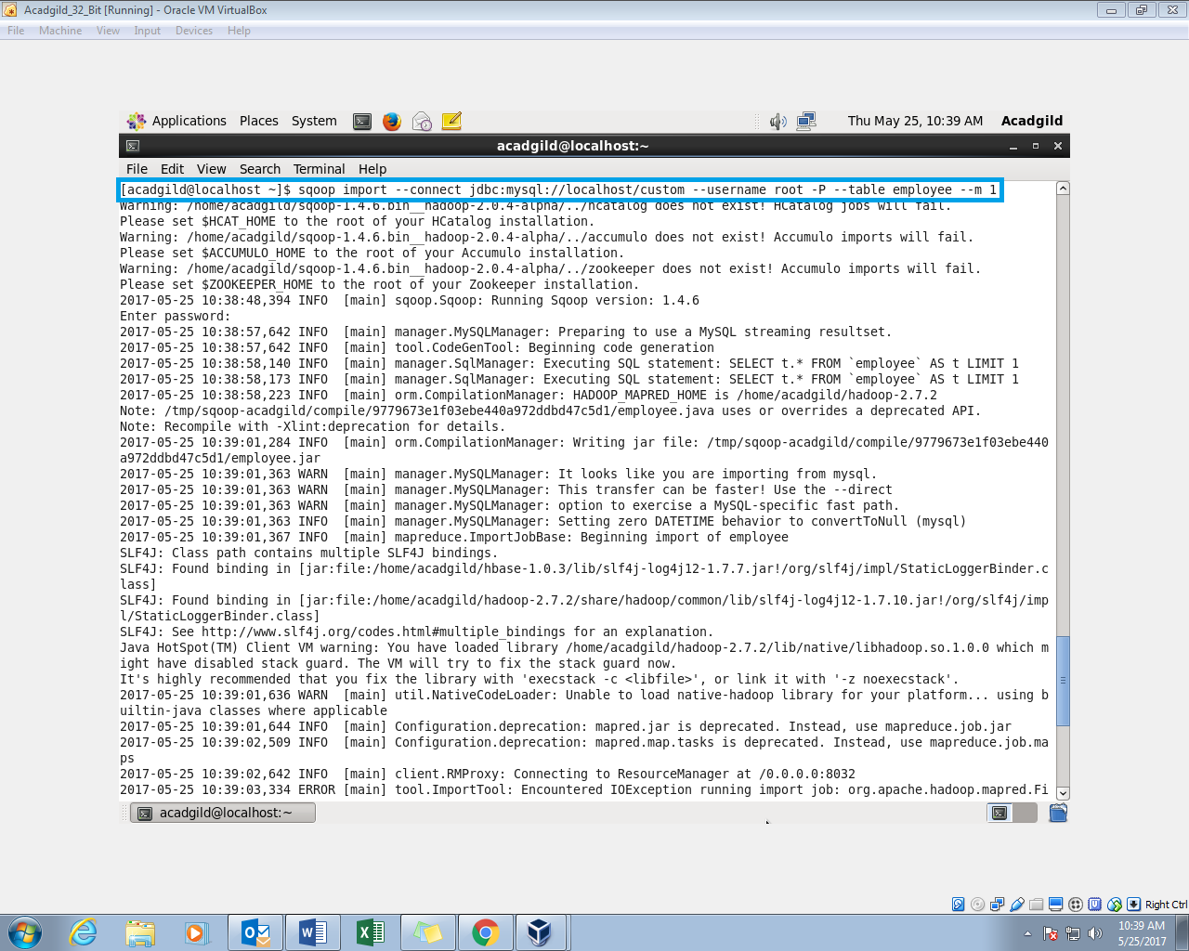

**Step 4**: The data is imported to the hdfs from mysql

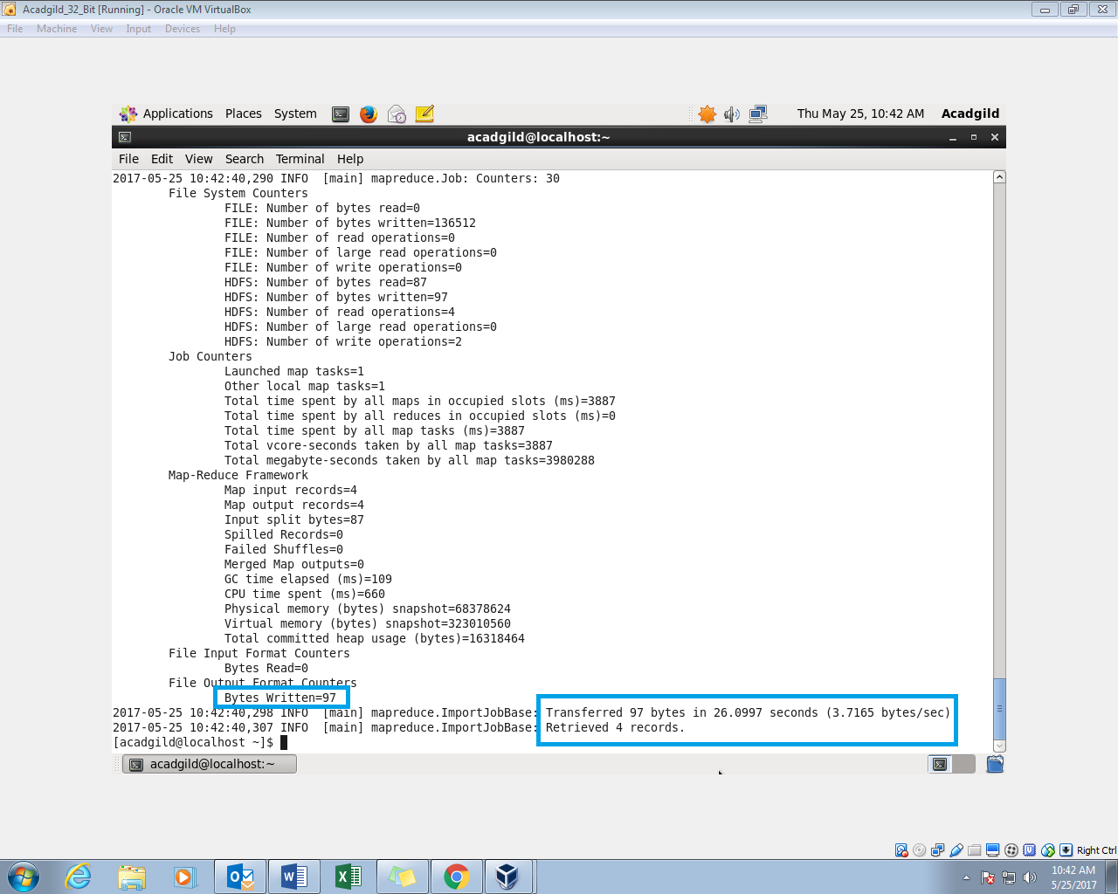

**Step 5:** List the files and reading the file using ls and cat command

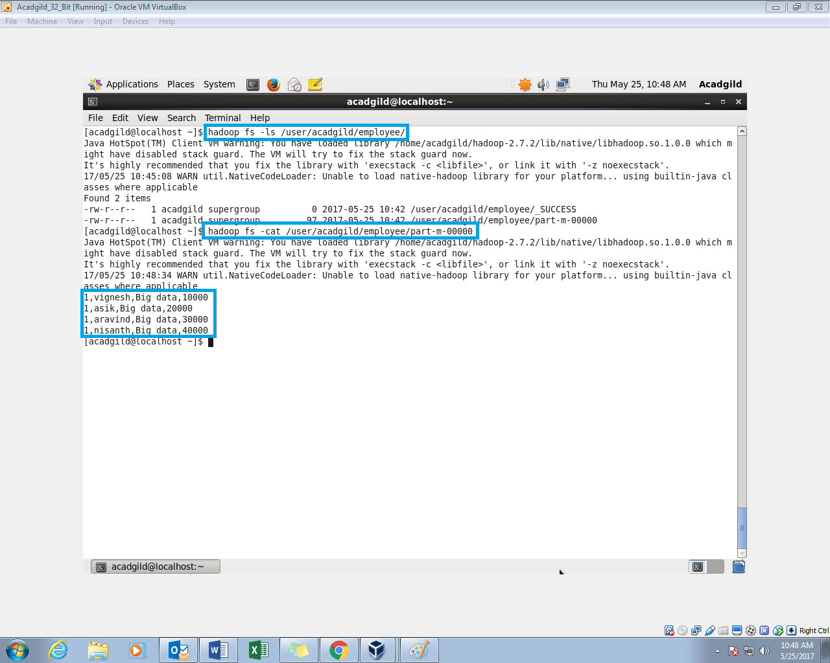

**QUESTION 2 :-**

* Create a employee2 table in Mysql and Export employee details file from HDFS directory to Mysql table employee2 using Sqoop.
* Explain the procedures performed, Share the screenshots of commands and results for the same.

**Step 1**: Create “employee2” table and keep it empty because we have to import it from hdfs

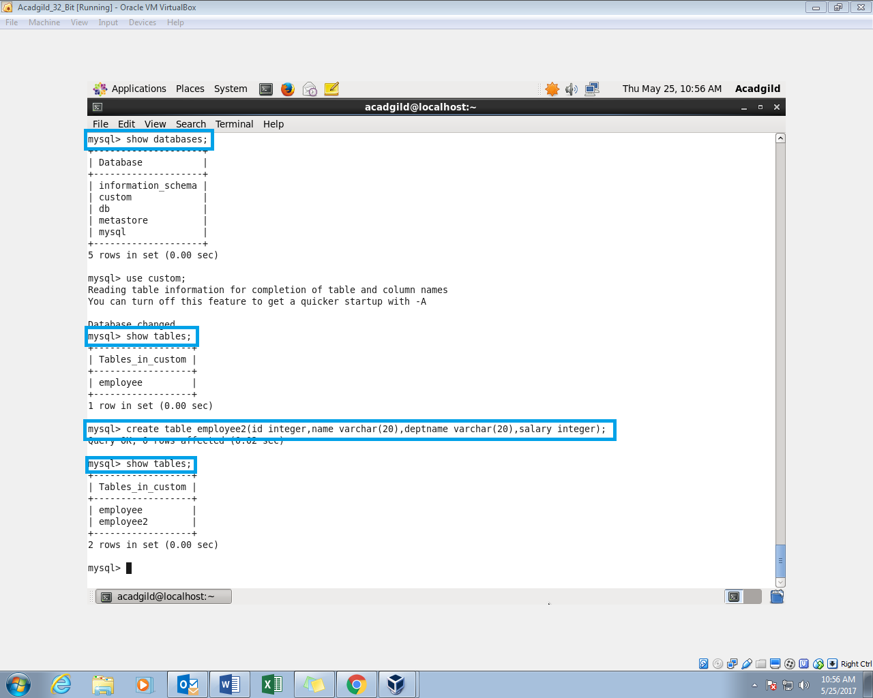

**Step 2**: Export the table from hdfs to mysql

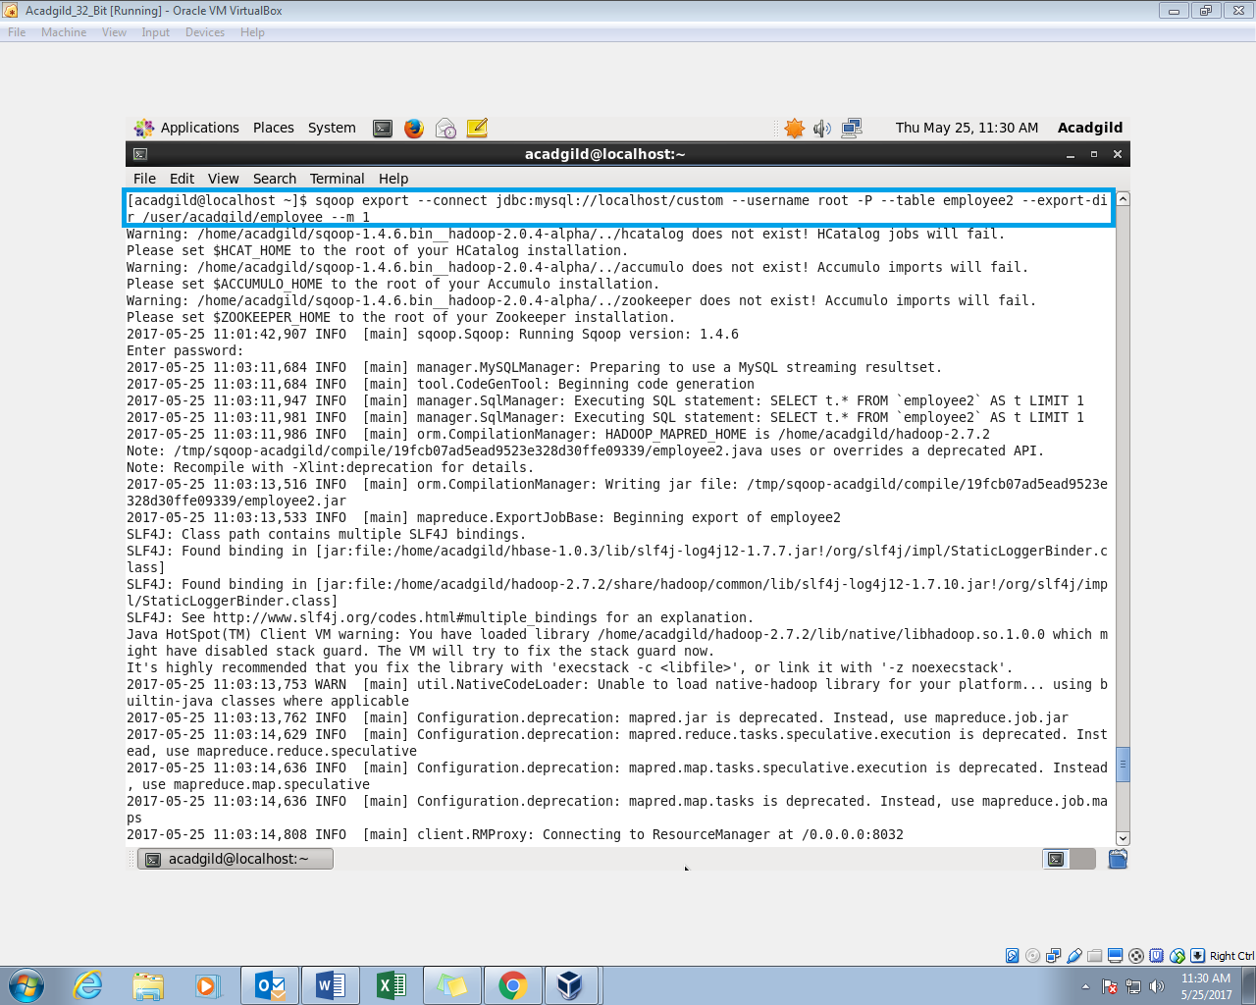

**Step 3** : successfully exported to mysql using scoop

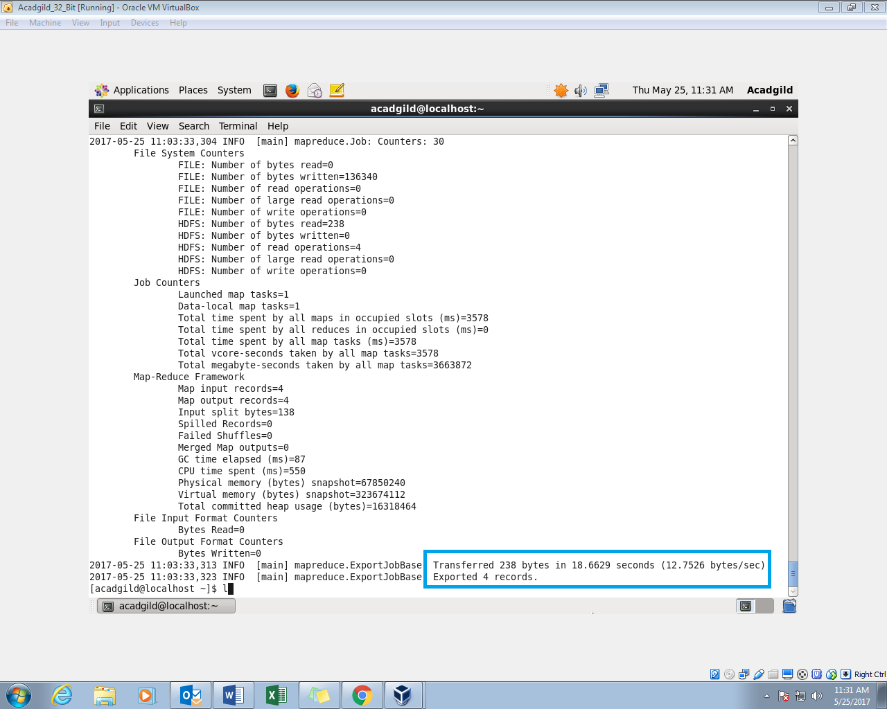

**Step 4**: Now this table contains data.

